Was This Florence Nightingale’s Piano?

The Square Piano used in today’s concert was originally bought from Embley Park many years ago. I was told “it might have been there when Florence Nightingale lived at Embley”

Trying to find some solid evidence to support this possibility has not been easy, though it has been very interesting. On one hand the property has changed hands twice and then became a school since their day but on the other hand an old broken piano whose legs have been glued in place so they can’t be unscrewed may well be left behind in a large old house when it is sold.

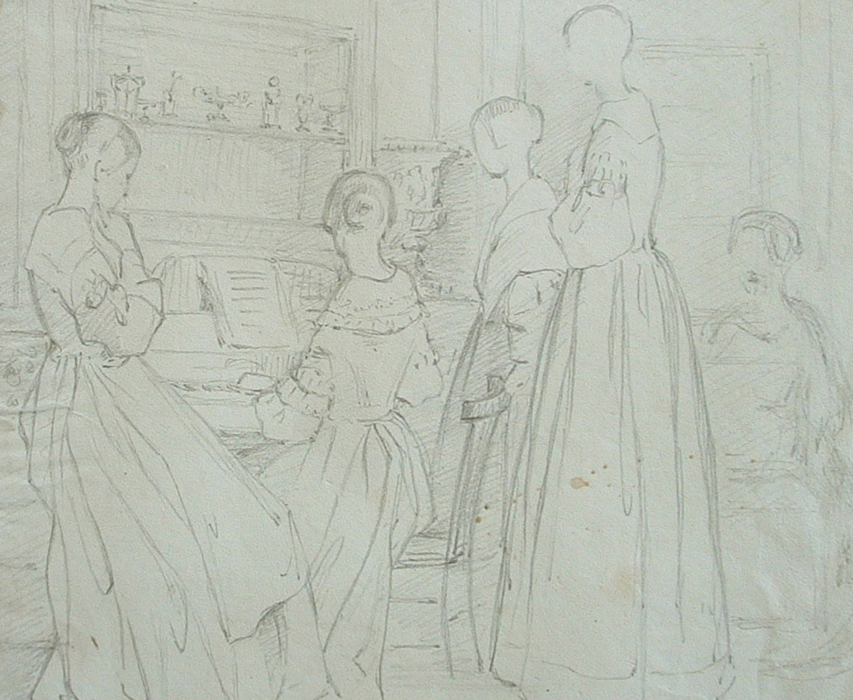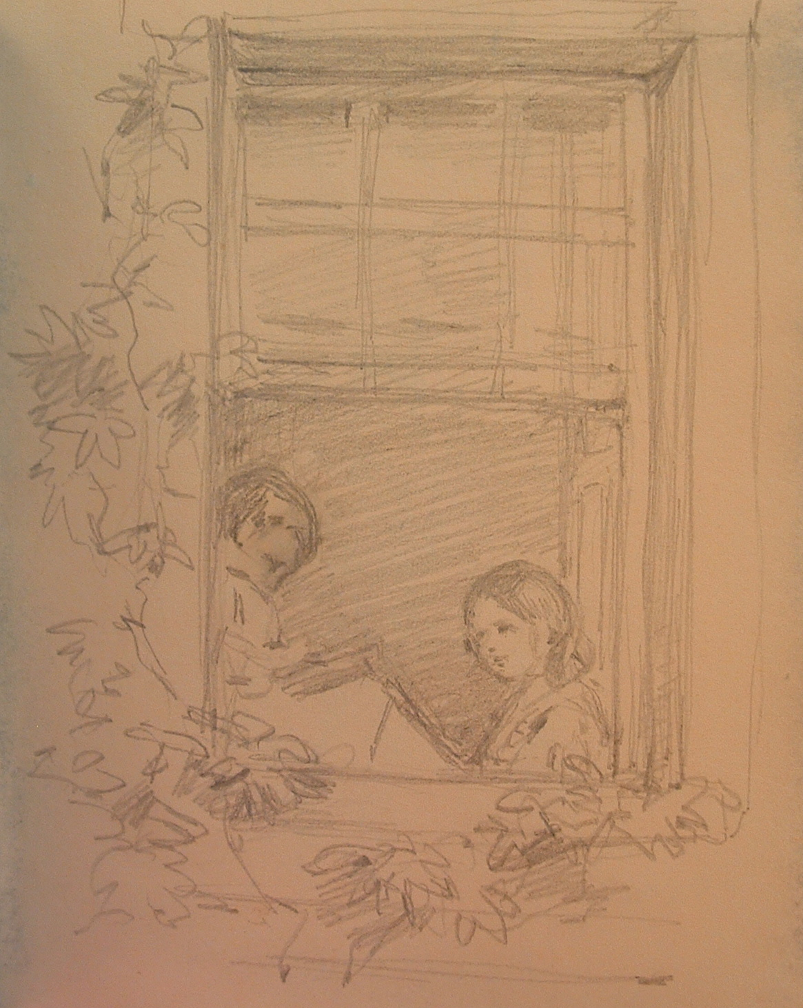
Left showing Florence (standing) with her family. Is it a square piano being played? Right. Through a window at Embley. Is Florence playing a square piano?

A search through the archives held at Winchester revealed some lovely drawings of members of the Nightingale family playing musical instruments and singing. Florence’s cousin and friend Hilary Bonham-Carter was a talented artist and left many sketches from the times they spent together either at Embley, or Lea Hurst. Embley Park, near Romsey in Hampshire, was bought by Florence’s father in 1825 and the family spent more time here, especially the winter months, than their other home, Lea Hurst, in Derbyshire. 1837 (the year this piano was built) was a significant year for Florence. She was seventeen years old and it was now she first heard a calling to serve God. It was also the time when she was ‘mad on music’. Mr. Nightingale was also planning to enlarge Embley and decided to take the family abroad while the work was carried out. Her letters from this journey make many references to operas, piano and singing lessons.

We know that the Nightingales hired a grand piano from Broadwoods for a while at Embley around 1851, perhaps to help steer Florence’s mind away from her nursing ambitions. Is it a coincidence that two of the keys of this square piano have the date of repair work 1851 written on them? It is possible that this square piano was becoming unplayable at this time. Evidence of poor quality repairs to the action could date from this time, the legs had become weakened and had to be permanently glued in place and many of the treble strings were broken. The severe wear of some of the ivories shows the piano had had a great deal of use and as hammers broke there was an attempt to keep it playing yet this seems to have been a vain effort.

About this Broadwood Square Piano.

The serial number is written in ink on the left hand part of the wrestplank, though it is not too clear now. However there are three other numbers written in ink or pencil on different components of the case and action. The clearest, inked in a beautiful hand on one on the keys, reads 49114 Wm. Sharpe.

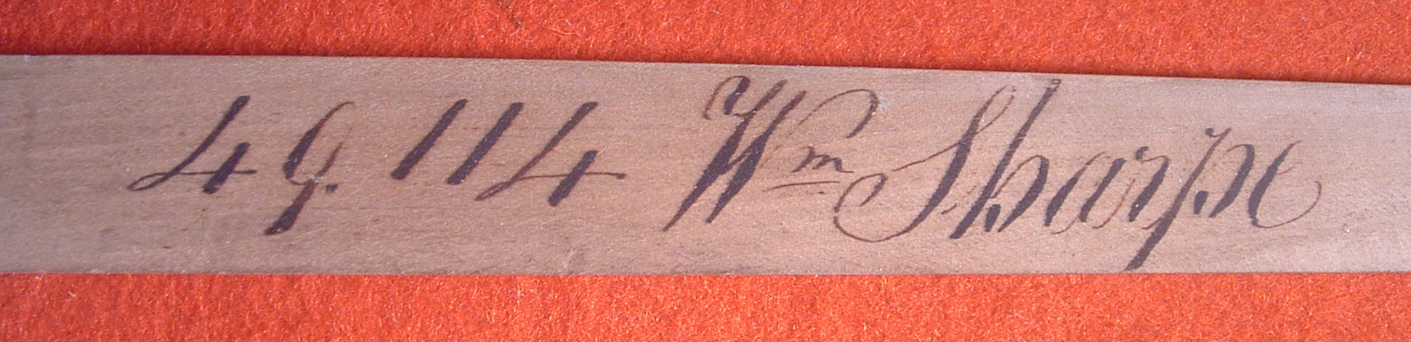

There are more signatures and dates elsewhere too but this can identify the piano as being made in 1837 as confirmed by the numbers book in the Broadwood archives. However the particular Porter’s book for this date, which would have told us the name of the first owner, has been flood damaged and is illegible. I have found out that many squares around this serial number were used as hire instruments but this one does not feature in those lists so it could have either been first sold directly to a customer or it could have gone to a retailer to be sold on. This line of enquiry unfortunately came to an inconclusive dead end.

During my restoration I found, amongst the dirt inside, some early dress maker’s pins, two needles, a button, a short twist of several threads, a flake of what appears to be slate and two grains of wheat. It is common to find small items within square pianos as they are quite open inside - coins, pieces of paper, beads etc, but this was an unusual hoard. The sewing items certainly suggest a female household practicing their skills, and there are several sketches of the two sisters sewing. The two grains of wheat puzzled me but the archives in Winchester revealed a sketch by Hilary Bonham Carter of three young children with a caption that reads “eating grains of wheat”. Another explanation might be that the piano was relegated to a barn or outbuilding for some of its life once it had no musical use and this could be how it remained in the property after the building was sold. (There were also bird droppings inside! But then Florence did have a pet owl by the way).

I could find no inventory or anything that could positively identify that the piano was in the house in the Nightingale’s time at Embley. But I did find a pair of photographs of their drawing room dating from a time after the property had been inherited by Mr. Nightingale’s nephew. The handwritten caption reads: Embley Drawing Room West window 1856 or 1861 Home of the Nightingales near Romsey, Hants. This drawing room was built on to the house by W. E. Nightingale (Uncle Night) after he bought the property from Mr. and Mrs Heathcote about the year 1835.The room is large and full of furniture. Behind an octagonal table and against the panelled wall there is a large rectangular object covered in a cloth, upon it are two shallow flower displays and a taller, slender flower pedestal. As far as it is possible to tell the proportions and shape would fit this square piano; it is frustrating that the legs are not visible at all. Many squares have indeed survived after their musical life has ended only because they served as useful sideboards. They are heavy and awkward to move and a cloth covering a piano was a common Victorian custom. The lid of this piano was badly stained with moisture and water had dribbled down between the two sections of the lid to the inside just where these flower vases might have sat. Although I have re-polished the lid as it was in such a poor condition the stains can still be seen inside and below the keyboard. The restoration has preserved as much original material as possible whilst returning the piano to a sound playable condition.

As yet I have not found any conclusive evidence to prove or disprove the provenance of this piano. This has been a brief outline of some of my discoveries so far. I hope to find more. Chris Barlow.

